INDIAFEST 2026- ADVERTISEMENT ORDER FORM
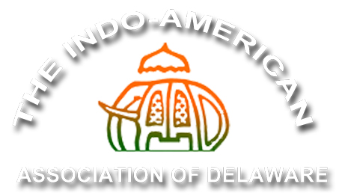
Saturday, September 26, 2026 – 11:30 AM to 8:00 PM

St. Mark’s High School
2501 Pike Creek Road, Wilmington, DE 19808

Banner Advertising Rate
- Banner (Max 3 ft. high X 8 ft. wide) with full page B/W ad $650
- Banner (Max 3 ft. high X 8 ft. wide) $550

Program Book Rate
- Back Cover (color) w/FB promotions on IAAD page $500
- Centerfold (color) w/FB promotions on IAAD page $500
- Inside Front Cover (Color) w/ FB promotions on IAAD page $500
- Inside Back Cover (Color) w/FB promotions on IAAD page $500
- Full Page (B/W) $250
- Half Page (B/W) $150

Contact name: Company name: Email:
Phone:
Total amount: $ Special Instructions (if any):

Please make checks payable to IAAD and mail the check and the completed advertisement form to: IAAD, 308 Bartram Lane East, Hockessin, DE 19707
Pay online at http://iaadelaware.org/sponsors.html and email the completed advertisement form to indiafestde@gmail.com

Program book advertisement Submittal Specifications
Please email your advertisement file directly to indiafestde@gmail.com
(Copy deadline Friday, September 14, 2026)
All program book ads must be submitted in PDF, Word or JPEG with at least 300 dpi resolution
Program book full-page ad dimensions 7.5” (H) x 5.0” (W)
Program book Half page ad dimensions 3.5” (H) x 5.0” (W)

Contact for any questions:
Aakansha Dhelia: (302) 981-7013 Email: indiafestde@gmail.com

