# IndiaFest 2025- ADVERTISEMENT ORDER FORM

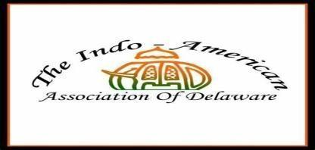

**Saturday, October 4, 2025 – 12:00 PM to 8:00 PM**

St. Mark’s High School

2501 Pike Creek Road, Wilmington, DE 19808

# Banner Advertising Rate

* Banner (Max 3 ft. high X 8 ft. wide) with full page B/W ad $600
* Banner (Max 3 ft. high X 8 ft. wide) $500

# Program Book Rate

* Back Cover (color) w/FB promotions on IAAD page $500
* Centerfold (color) w/FB promotions on IAAD page$500
* Inside Front Cover (Color) w/ FB promotions on IAAD page $500
* Inside Back Cover (Color) w/FB promotions on IAAD page $500
* Full Page (B/W) $250
* Half Page (B/W) $150

**Contact name:**  **Company name:**  **Email:**

**Phone:**

**Total amount: $**  **Special Instructions (if any):**



Please make checks payable to IAAD and mail the check and the completed advertisement form to: **IAAD, 308 Bartram Lane East, Hockessin, DE 19707**

Pay online at <http://iaadelaware.org/sponsors.html> and email the completed advertisement form to [indiafestde@gmail.com](mailto:indiafestde2024@gmail.com)

# Program book advertisement Submittal Specifications

**Please e mail your advertisement file directly to** [indiafestde@gmail.com](mailto:indiafestde2024@gmail.com)

**(Copy deadline Friday, September 24, 2025)**

All program book ads must be submitted in PDF, Word or JPEG with at least 300 dpi resolution

Program book full-page ad dimensions **7.5” (H) x 5.0” (W)**

Program book Half page ad dimensions **3.5” (H) x 5.0” (W)**

# Contact for any questions:

Aakansha Dhelia: (302) 981-7013 Email: [indiafestde@gmail.com](mailto:indiafestde2024@gmail.com)